A Project Report on

IQ - ShieldNet: A Hybrid Image -

Quality - Aware Deep Multimodal

Framework for Biometric Anti Spoofing
Submitted to
The Department of Information Technology

In partial fulfillment of the academic requirements of Jawaharlal Nehru Technological University for
The award of the degree of Bachelor of Technology
in InformationTechnology
(2022 – 2026)

By
P Sumanth 22311A1216
M Samatha 22311A1259
A Sathwik 22311A1263

Under the Guidance of

Dr. Sunil Bhutada
Associate Professor & Associate Head


Sreenidhi Institute of Science and Technology
(An Autonomous Institution)
Yamnampet, Ghatkesar, R.R. District, Hyderabad –501301

Sreenidhi Institute of Science and Technology

Department of Information Technology



CERTIFICATE

This certifies that the “IQ- ShieldNet: A Hybrid Image-Quality-Aware Deep Multimodal Framework for Biometric Anti Spoofing”, Project II report, which was submitted by P Sumanth (22311A1216), M Samatha (22311A1259), A Sathwik (22311A1263), in the year 2026 in partial fulfillment of the academic requirements of Jawaharlal Nehru Technological University for the award of the degree of Bachelor of Technology in INFORMATION TECHNOLOGY, is a genuine project work that has been carried out by them as part of their Project during Fourth Year second Semester, under our guidance and supervision. This report has not been submitted to any other institute or university for the award of any degree.

Internal Guide & Project Coordinator Head of department

Mr. M. Nagaraju & Dr. Sunil Bhutada
Associate Professor & Associate Head Professor & Head Department of IT

External Examiner
Date:

DECLARATION

We the students P Sumanth (22311A1216), M Samatha (22311A1259), A Sathwik (22311A1263), students of

SREENIDHI INSTITUTE OF SCIENCE AND TECHNOLOGY, YAMNAMPET, GHATKESAR,
studying IV-year II semester, INFORMATION TECHNOLOGY solemnly declare that the Project-II work, titled “IQ- ShieldNet: A Hybrid Image-Quality-Aware Deep Multimodal Framework for Biometric Anti Spoofing” has been submitted to SREENIDHI INSTITUTE OF SCIENCE AND TECHNOLOGY for partial fulfillment for the award of degree of Bachelor of technology in INFORMATION TECHNOLOGY.
It is declared to the best of our knowledge that the work reported does not form part of any dissertation submitted to any other University or Institute for award of any degree.

P Sumanth (22311A1216)
M Samatha (22311A1259)
A Sathwik (22311A1263)

ACKNOWLEDGEMENT

I would like to express my gratitude to all the people who worked behind the scenes, who helped me to transform an idea into a real application.
I would like to express my heart-felt gratitude to my parents, without whom I would not have been privileged to achieve and fulfill my dreams. Our CEO-Mr. K. Abhijit Rao, Director Prof. Dr. C.V. Tomy and Principal Dr. T. Ch. Siva Reddy, who most skillfully manage the institution and have played a significant role in allowing me to do complete my research, and my project.
I profoundly thank Dr. Sunil Bhutada, Head of the Department of Information Technology, who has been a tremendous mentor and inspiration for my work.
I want to express my gratitude to our Coordinator and my internal guide Dr. Sunil Bhutada for Project-II for his technical guidance, encouragement, and support in carrying out my project on time at college.

The satisfaction and euphoria that accompany the successful completion of the task would be great but incomplete without the mention of the people who made it possible with their constant guidance and encouragement crown all the efforts with success. In this context, I would like to thank all the other staff members, both teaching and non-teaching, who have extended their timely help and eased my task and offered prompt assistance.

P Sumanth (22311A1216)
M Samatha (22311A1259)
A Sathwik (22311A1263)

ABSTRACT

Users can authenticate their identity by using their unique physical traits through biometric authentication systems. The standard single-modality systems operate with two security weaknesses which attackers use for their spoofing attacks and the systems fail to function under various environmental conditions. The project introduces IQ - ShieldNet: A Hybrid Image - Quality - Aware Deep Multimodal Framework for Biometric Anti-Spoofing to solve existing problems by combining deep learning technologies with image quality assessment to create better security solutions. The system utilizes three biometric modalities which include face recognition fingerprint recognition and iris recognition through Convolutional Neural Networks (CNNs) to achieve effective feature extraction. An IQA mechanism lets the system detect both poor-quality inputs and spoofing attempts which enhances its defense capabilities against presentation attacks that use fake images masks or synthetic data for their attacks. The framework establishes multiple authentication options by implementing a process which grants authentication rights through successful verification of two biometric modalities from one individual. The method enhances user experience while preserving strong protection against attacks that use multiple biometric identification methods. The system enables matching through similarity metrics which include cosine similarity because it stores extracted features in a database. The testing results show that the system achieves better authentication accuracy while decreasing false acceptance rates and improving performance in real-world situations. The system maintains security through its protective measures while providing users with efficient performance and easy-to-use access control systems which function as identity verification tools for secure access control. The system will enhance its ability to function in actual environments through the implementation of transformer-based deep learning models which will work across cloud and mobile devices together with real-time liveness detection systems.

INDEX

CONTENTS | Page No
1.INTRODUCTION | 1-4
1.1 Objective | 1-2
1.2 Problem Statement | 3
1.3 Proposed System | 3- 4
2. LITERATURE SURVEY | 5-8
2.1 Peer existing systems | 5-8
3. SYSTEM ANALYSIS | 9-10
3.1 Software Requirements | 9
3.2 Hardware Requirements | 10
4. SYSTEM DESIGN | 10-19
4.1 Architecture of Proposed System | 10-11
4.2 UML Diagrams | 12-19

5. IMPLEMENTATION | 20-58
5.1 Language/Technology used for implementation | 20-36
5.2 Algorithms Implemented | 36-58
6. TESTING | 59
7. RESULT AND ANALYSIS | 60-62
8. CONCLUSION | 63-65
9. REFERENCES | 66

List of Figures:

FIG.NO | FIG.NAME | PG.NO
4.2.1 | Use case diagram | 13
4.2.2 | Sequence diagram | 15
4.2.3 | Class diagram | 17
4.2.4 | Activity diagram | 19

CHAPTER I

INTRODUCTION

The digital environment today needs secure identity verification methods which provide constant reliability for banking, healthcare, surveillance, and access control systems. The increased theft problems which exist today make it more dangerous for people to depend on password and ID card authentication systems. Biometric authentication has established itself as vital because it enables secure identity authentication through specialized human characteristics which includes facial recognition, fingerprinting, and iris scanning.

The biometric systems of today face their most dangerous security risk through criminal spoofing attacks which enable criminals to present fake biometric materials that include printed photographs as well as artificial fingerprints and synthetic iris patterns to trick the authentication system. The identification of these attacks becomes more difficult for traditional systems because advanced technology enables the creation of deepfakes and AI-generated data.

Most existing systems either use single biometric technology or need multiple biometric identification systems according to their multimodal system requirements. Single-modality systems experience security vulnerabilities through their single point of failure, while traditional multimodal systems, which require all biometric data to match for identification, produce usability problems and higher rejection rates when input quality decreases.

The solution to these problems comes from IQ-ShieldNet: A Hybrid Image Quality-Aware Deep Multimodal Framework for Biometric Anti-Spoofing which this project presents. The system uses Image Quality Assessment (IQA) technology together with deep learning methods to detect low-quality and spoofed inputs which need authentication. Convolutional Neural Networks (CNNs) function to obtain strong face and fingerprint and iris image features through their extraction process.

The proposed system includes authentication flexibility which enables access to users who succeed in verifying two biometric methods that authenticate their identity. The system enhances usability while preventing unauthorized access through mixed-biometric attacks and maintaining security strength.

The system IQ-ShieldNet combines multimodal biometric technology with image quality analysis and deep learning authentication methods to establish a secure user-based authentication system which provides equal access to all users.

Objective
The IQ-ShieldNet platform creates a secure intelligent system which uses multiple biometric authentication methods to identify users while it protects against spoofing attacks and delivers real-time operational capabilities. The system uses deep learning technology together with image quality assessment to provide dependable authentication results which do not need specialized high-cost authentication equipment.

Smart Image Quality-Based Anti-Spoofing
    - Analysis of biometric input based on Image Quality Assessment (IQA).
    - Detection of images with low quality or images that have undergone modification to determine spoofs.
    - Pre-screening for fraud prior to conducting feature extraction from biometric input.
    - This will ensure that any attempt made for an attack will be detected earlier.

Deep Learning-Based Feature Extraction
The exact process of identification through biometrics would take place in the following manner:
    - Using CNN for feature extraction from faces, fingerprint and iris.
    - Creating higher level features which would make classification of classes easier.
    - Increasing the efficiency of recognition systems in various environmental condition
    - Makes the system more proficient in differentiating between the real and fraud user.

Flexible Multimodal Authentication Mechanism
The following measures will be put in place so as to ensure the highest security and convenience:
    - A measure whereby just two out of the three biometric entries will be enough to verify identity.
    - This will help avoid over reliance on the three biometric entries hence simplifying things for the user.
    - As a measure of verifying that the two biometric entries belong to one individual.

Efficient Feature Matching and Decision Making
To be able to decide correctly on the authentication process, the platform needs to:
    - Determine the degree of similarity between the extracted characteristics and the templates, for instance, by employing the cosine similarity approach.
    - Decide on the threshold that will determine whether authentication succeeded or failed.
    - Build the template database.

User-Friendly Interface and Real-Time Performance
To enhance usability and accessibility, the following can be done in this regard:
    - The system will be developed using Flask and other frontend frameworks.
    - It will have the facility to upload images and even capture an image using the user’s camera.
    - The outcome of the verification process will also be provided.
    - Consequently, there will be no problem for the user at all.

Problem Statement
Owing to the nature of this development in the digital age, it has led to biometric identification systems being used widely in areas such as banking and access control. Single-modality systems are common in these areas; therefore, it is easy for attacks on these systems to be made. This kind of attack is quite easy for the attacker to perform since all he needs to do is to present fabricated biometric information such as false faces to the system.

The next important concern is that the recognition algorithm does not take into account the quality of the image or data used for recognition. Bad-quality pictures, noises, or anything else can significantly impair the system's operation and cause incorrect recognition of the user's identity. Also, modern ways of cheating, like using artificial intelligence technology to create a deepfake, are an important concern.

Although the work that has been done with respect to multimodal biometrics has been directed towards ensuring the security of the system, it makes the system less usable and increases the probability of false acceptance because of the principle upon which it operates. This is because currently there are no security measures which would address attacks carried out by combining the biometrics of two different people.

Proposed System

An Integrated AI-Based Multimodal Biometric Framework
IQ-ShieldNet can be seen as an intelligent design which is highly secure, and no compromises have been made regarding ease-of-use by the users. On the contrary, it has made things very easy by offering far greater flexibility than solutions that rely on a single biometric authentication method or match biometrics precisely.

Image Quality-Aware Anti-Spoofing Mechanism
The process of spoof detection using the method of IQA is the fundamental idea that works behind the IQ-ShieldNet algorithm. IQ-ShieldNet algorithm calculates the quality level of the biometric images fed to the algorithm as inputs based on certain factors such as blurriness, noise, distortion, and anomaly. These factors can appear if the given biometric data is fake. Only those inputs with good quality are used for analysis, while those with poor quality are ignored.

Deep Learning-Based Feature Extraction
CNN’s applicability is seen in this process where the facial features, fingerprints, and irises are analyzed. This is because CNN allows training which will make the system able to identify even the most complicated texture and patterns in images. In this way, it will be difficult for the system to be affected by any changes such as lighting conditions and change in the position of an image. This is done by transforming features into numbers.

Flexible Multimodal Authentication Strategy
Unlike others where authentication is determined by the success of the combination of all used modalities, in the case of the scheme known as IQ-ShieldNet, only two of the three modals are required. They must be provided by one person.

Efficient Matching and Decision Engine
The method involves comparing the created vector with the saved template using the similarity function that includes cosine similarity. There is a threshold decision rule that determines the effectiveness of the whole authentication process. It is safe to store biometric templates and vectors in the database.

User-Friendly and Scalable Web Application
This system provides an easy-to-use online user interface which has been developed using Flask and other front-end frameworks. The users are free to upload their biometric images or capture their pictures via their webcams. There is feedback provided regarding the authentication process, as well as the results of the authentication. This cost-effective system requires no special hardware devices.

CHAPTER II

LITERATURE SURVEY

In the field of biometrics, significant progress has been achieved through the application of AI and DL, contributing to the development of smart biometrics for securing purposes. In order to improve security measures, CNNs, generative models, and multimodal fusion techniques have gained popularity because of their capability to address issues related to spoofing and feature extraction.

Recent studies indicate that the deep learning algorithm has been successful in the development of anti-spoofing techniques. For example, Ametefe et al. have investigated different techniques for determining whether the fingerprint comes from live or non-live subjects and concluded that the deep learning-based approach is effective relative to other techniques [1]. Similarly, Rufai et al. have shown that the deep learning-based approach is more effective than other approaches for iris-based anti-spoofing applications [2].

The adoption of multi-modal biometric techniques has played a significant role in improving the efficiency of the process of authentication. As stated by Shabana & Balakrishna [9], multi-modal deep learning techniques which are founded on facial recognition, fingerprint and iris scanning, have proven to yield robust and efficient results in ensuring that the process of authentication is protected from being attacked. Geometrical and temporal methods have been employed for face anti-spoofing attacks using two-dimensional images as noted by Parvadhi et al. [4]. Jenkins & Roy [3] have elaborated on the importance of deep convolutional GANs for biometrics.

However, there are a number of issues associated with biometrics-based authentication mechanisms. As indicated by Hajare and Ambhaikar [8], there are some limitations concerning computation in real time and lack of robustness under different lighting situations. According to Parmar and Gupta [5], traditional machine learning algorithms are not able to handle new types of threats. Also, as indicated by Lokhande et al. [7], the effectiveness of the system largely depends on the quality of input data.

The above-mentioned constraints have made it necessary to develop sophisticated techniques such as the IQ-ShieldNet algorithm that falls under the category of hybrid technique. The implementation of IQ evaluation procedures, along with the utilization of the deep learning technique in feature extraction, aims at enhancing its efficiency and accuracy levels.

Peer Existing Systems
However, biometric authentication has been embraced widely in recent years owing to the ability of the technology to offer enhanced security and reliable identification. However, the existing biometric systems only focus on the features of the user of the systems, ignoring other factors. This is because currently there exist only single modality biometric systems, where one is able to authenticate the use of only one feature, such as fingerprints or facial recognition, in order to access the biometric system. In this light, it is possible to access the system easily by using fake features. Flexibility in multimodal biometric systems has not been achieved.

Overview of Existing Systems
Several techniques have been employed with the aim of achieving a quick and efficient way of identifying individuals. Such a case applies to face recognition technology, whereby authentication is achieved through the use of facial pictures. While the technique is widely accepted due to its speed, it is highly vulnerable to deception, such as paper deception and video deception. Another example of an authentication method is fingerprint authentication technology. While more reliable compared to the previous one, it can easily be fooled by artificial fingerprints.

    - Face Recognition System can be found in mobiles and security systems because of its efficiency. However, Face Recognition System is highly susceptible to attacks such as photos, videos, and deepfakes. It concentrates more on face recognition but does not have an approach that combats fake faces.

    - Fingerprint Authentication Systems have been extensively used in banks and security systems because of their effectiveness and distinctiveness. Although they are relatively more accurate than face recognition systems, they are vulnerable to attacks that deceive the system into accepting artificial fingerprints produced from silicone and gelatin materials.

    - The iris recognition system is considered to be extremely secure due to the special nature of the irises; this type of authentication is applied in highly secure locations. On the other hand, it is dependent upon certain technology and environmental factors. Furthermore, it may be subject to spoofing by means of high-resolution printouts or contact lenses.

    - Finally, Multimodal Biometric System refers to a class of system which uses various features such as face features, fingerprints, and irises for improved identification. However, these systems have stringent criteria whereby a match between all the features is required before authentication, hence posing a challenge with regard to their effectiveness. They do not have the ability to resist spoofing either.

Comparison Table: Peer AI-Based Agricultural Systems

System Name | Core Feature | Limitation
Face Recognition Systems | Identity verification using facial image analysis and pattern recognition | Vulnerable to spoofing (photos, videos, deepfakes); affected by lighting and pose variations
Fingerprint Authentication Systems | Biometric verification using unique fingerprint patterns | Can be spoofed using artificial fingerprints; lacks quality-based validation
Iris Recognition Systems | High-security authentication using unique iris patterns | Requires specialized hardware; sensitive to environmental conditions and user cooperation
Multimodal Biometric Systems | Combines face, fingerprint, and iris for improved accuracy | Rigid requirement of all modalities; reduces usability and increases failure rates
Deep Learning-Based Systems | Uses CNN models for feature extraction and improved recognition accuracy | High computational cost; requires large datasets and lacks integrated spoof detection

Why IQ-ShieldNet Stands Out

Unlike the systems mentioned above, the IQ-ShieldNet system is an all-in-one biometric authentication system based on artificial intelligence technology that can be used in practical security situations. The system includes various functions such as spoof detection using image quality, deep learning feature extraction, multimodal authentication flexibility, and effective similarity comparison within a single system.

The technology makes the system accessible because of the incorporation of a friendly web interface that does not require any specific software, such as infrared detector and sophisticated biometric software. The IQ-ShieldNet technology can be scaled and used in economically challenging environments. The technology incorporates the idea of spoofing detection, quality awareness, and adaptive authentication into one cost-efficient technology. This technology corrects the limitations present in the other biometric systems and therefore becomes an intelligent biometric authentication system.

CHAPTER III

SYSTEM ANALYSIS

Software Requirements

Operating System:
Compatible with Windows, Linux, or macOS for development and deployment flexibility.

Coding Languages:
Python for backend processing, model development, and system integration; HTML, CSS, and JavaScript for frontend development.

Development Tools & Libraries:
- OpenCV: Image processing and biometric feature extraction.
- TensorFlow & Keras: Deep learning model development (CNN, LSTM).
- Scikit-learn: Machine learning algorithms and evaluation.
- Pandas, NumPy: Data processing and numerical computations.
- Matplotlib: Visualization of performance metrics and results.

Database:
SQLite or MySQL for storing biometric templates, user records, and authentication logs.

Dataset Sources:
- LivDet, CASIA, OULU-NPU: Benchmark biometric datasets for training and evaluation.
- Custom Biometric Inputs: Face, fingerprint, and iris images captured for system testing.

Frameworks:
- Flask/Django: Backend framework for handling requests and authentication workflows.
- Web Technologies: HTML, CSS, JavaScript for building user interfaces.

Hardware Requirements

System:
A 64-bit processor (standard PC or laptop) such as Intel i5/i7 or AMD equivalent for efficient processing of biometric data.

Storage:
Minimum 256 GB of storage (SSD preferred) for faster data access, model loading, and database operations.

Display:
A 15.6-inch or larger HD display for clear visualization of biometric inputs, system outputs, and user interface.

Input Devices:
Standard keyboard and optical USB or wireless mouse for smooth interaction with the system.

    - RAM:
Minimum 8 GB RAM for handling image processing and authentication tasks.
16 GB RAM is recommended for better performance during deep learning model training and real-time processing.

Graphics Card:
Optional but recommended GPU (e.g., NVIDIA GTX/RTX series) for accelerating CNN-based feature extraction and model training.

Camera & Biometric Devices: HD webcam for face capture; optional fingerprint scanner and iris capture devices for multimodal authentication.

Internet Connection:
Stable internet connection for system updates, optional cloud deployment, and real-time data synchronization.

CHAPTER IV

SYSTEM DESIGN

Architecture of Proposed System
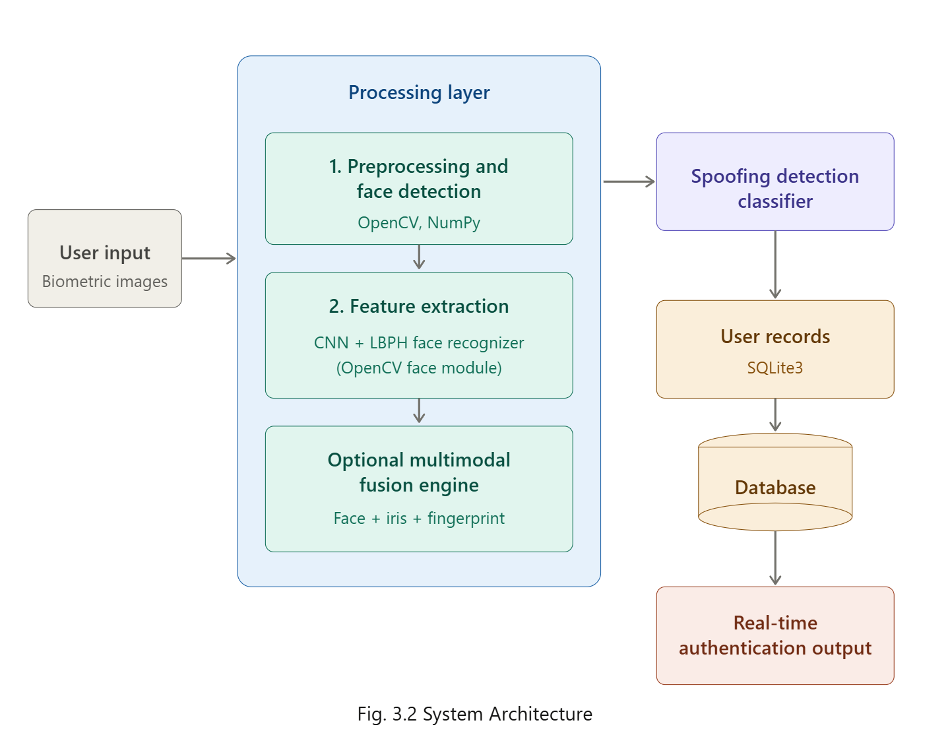
The proposed system follows a modular and layered architecture that has been carefully designed to remain scalable, deliver real-time performance, and ensure accurate user authentication. As shown in the architecture diagram, the system is made up of several interconnected components that work together to capture, process, and verify multiple biometric modalities such as the face, iris, and fingerprint. Every layer in the pipeline is assigned a specific role, and when combined, these layers form a smooth and efficient workflow that makes the entire authentication process both reliable and fast.
- Input Layer: This is the starting point of the system, where the user's biometric data is collected. Inputs can be provided in two ways — by uploading images directly for offline analysis or by capturing them live through a webcam using OpenCV. Supporting both options makes the system adaptable to different real-world deployment scenarios.
- Preprocessing and Face Detection: Once the input is received, it undergoes a series of image enhancement steps such as resizing, grayscale conversion, and noise removal, carried out with the help of OpenCV and NumPy. These operations help standardize the image quality before further processing. A Haar Cascade Classifier is then used to automatically locate and crop the facial region, ensuring that the later stages operate only on the meaningful parts of the image.
- Feature Extraction: This module forms the core of the recognition pipeline and follows a hybrid approach. Deep learning models built with TensorFlow and Keras — particularly Convolutional Neural Networks (CNNs) — are used to learn high-level and discriminative features, while traditional techniques like the Local Binary Pattern Histogram (LBPH) and frequency-based texture analysis are applied to fingerprint and iris samples. The extracted features are then normalized into compact numerical vectors, making them easier to compare during the matching process.
- Multimodal Fusion Engine: To make the system more secure, an optional fusion component combines information drawn from the face, fingerprint, and iris modalities. Since authentication is only successful when all three identifiers match, this layer greatly reduces the chances of spoofing and identity theft, offering an added layer of protection against impersonation.
- Spoofing Detection Classifier: Before the final verification, the extracted features are checked by a spoofing detection classifier that determines whether the input is authentic or has been artificially created or manipulated. This step ensures that only genuine, non-tampered samples proceed to the final authentication stage.
- User Records Database: All registered user information, including biometric templates and authentication history, is stored in a structured SQLite3 database. This setup supports fast retrieval of records and enables the system to maintain reliable logs for both verification and long-term management.
- Real-Time Authentication Output: The final results are displayed through a Flask-based web interface, which provides instant feedback to the user. Access is granted only when all biometric inputs correctly match the stored records; if there is a mismatch or any issue, the system responds with clear and informative feedback for the user or administrator.
- Technology Integration: The overall system brings together Flask for web interaction, OpenCV for capturing and processing images, TensorFlow for deep learning–based feature extraction, and SQLite for managing user data. Together, these technologies enable an accurate, real-time, and scalable multimodal biometric authentication experience.

UML Diagrams
In this project, Unified Modeling Language (UML) diagrams are used to visually represent both the structure and the behavior of the proposed Multimodal Biometric Authentication System. These diagrams play an important role in understanding the overall architecture, the workflow of operations, and the communication between the various modules such as user registration, feature extraction, database storage, and authentication.
Different types of UML diagrams are used to capture different aspects of the system. The Use Case Diagram highlights the interactions between the user and the core system functions, such as registering a new person or performing authentication. The Class Diagram provides a logical design view by illustrating the relationships between the key classes involved in image processing, CNN-based feature extraction, and database management. The Sequence Diagram describes the step-by-step flow of events between components during the authentication process, while the Activity Diagram presents the overall operational flow of the system in a more procedural form. Together, these UML models simplify the system design, improve readability, and support effective communication among developers throughout the development lifecycle

Module Connectivity Diagram
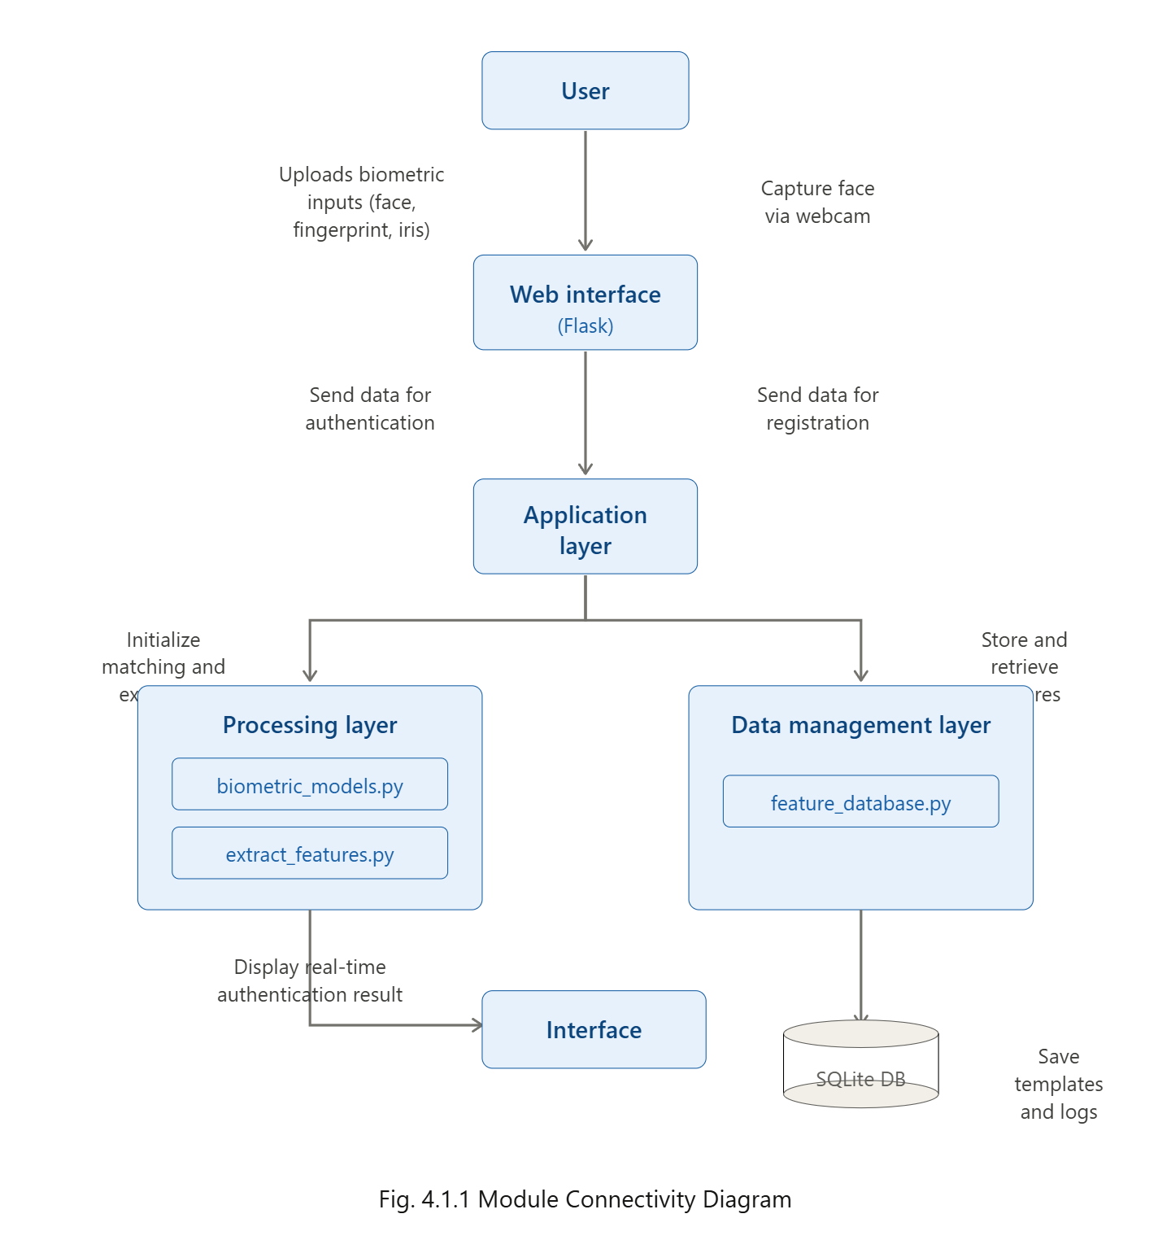

To better illustrate the internal workflow of the proposed system, a Module Connectivity Diagram has been included. This diagram provides a clear view of how data travels between the different components of the biometric authentication framework and how each module communicates with the others to complete the overall process.
The workflow begins when the user submits their biometric inputs — including face, fingerprint, and iris samples — either by uploading them through the index.html page or by capturing them live from a webcam using webcam_capture.py. These inputs are then forwarded through the Flask-based web interface to app.py, which serves as the central controller of the entire system and manages the coordination between all backend modules.
From there, setupp.py takes charge of initializing the biometric matcher and establishing communication with biometric_models.py, where CNN-based feature extraction is performed. The extracted biometric data is then handed over to feature_database.py, which is responsible for securely storing and retrieving biometric templates from the SQLite database. Whenever a new user is registered through the add_person.html page, extract_features.py is invoked to carry out batch feature extraction, ensuring that every registered user's biometric template is accurately processed and stored before being added to the system.
During authentication, the newly captured biometric features are carefully compared against the templates already stored in the SQLite database. Once the comparison is complete, the matching results are passed back to app.py, which applies the required business logic — such as validating the user and determining whether access should be granted — before displaying the final outcome on the web interface for the end user.
One of the major strengths of this architecture lies in its modular design. By separating responsibilities across well-defined modules, the system becomes easier to scale, manage, and extend. This structured flow not only simplifies maintenance but also ensures that data is handled efficiently and securely at every stage, making the system practical for both academic demonstrations and real-world biometric authentication applications.

Class Diagram

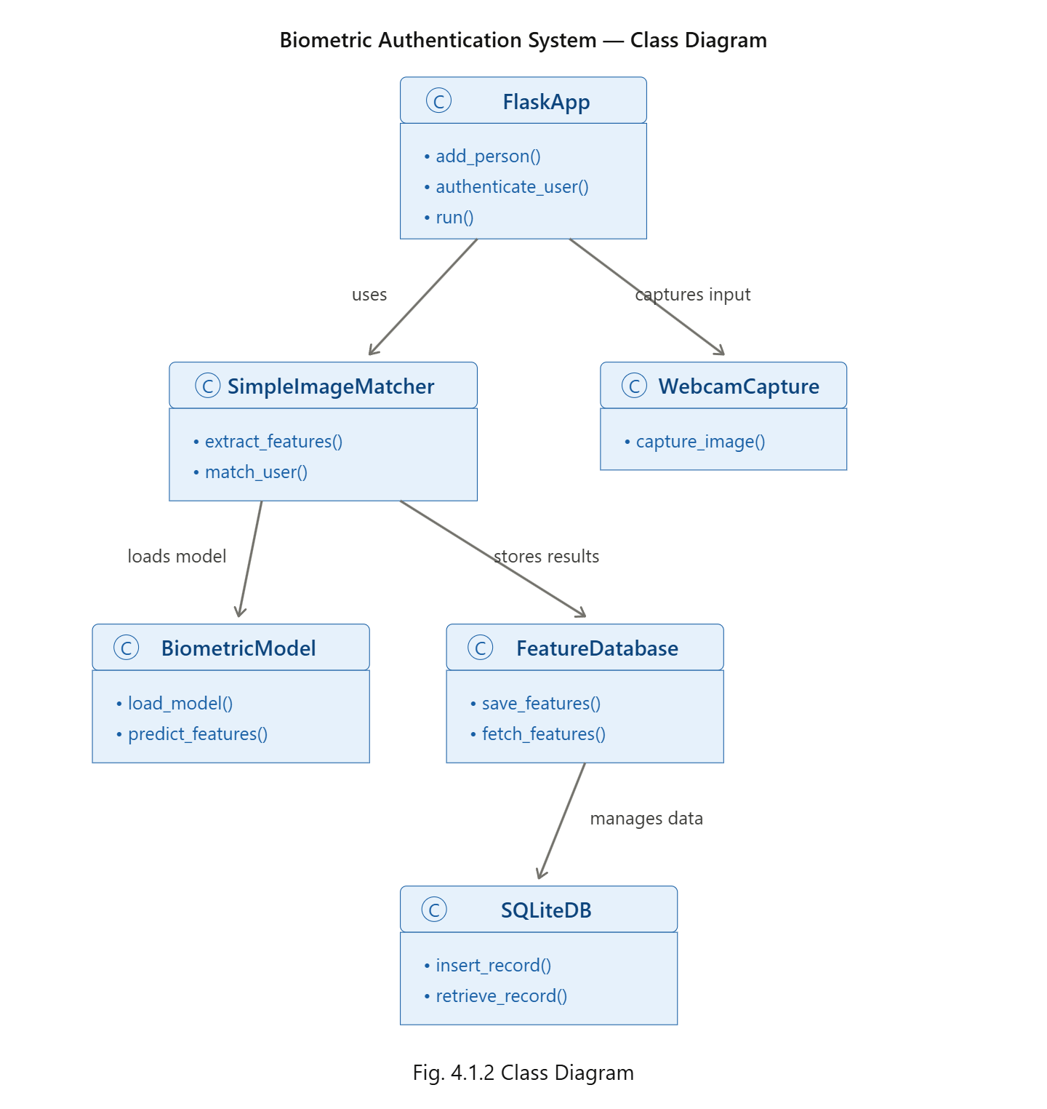

The Class Diagram presents the structural and functional blueprint of the proposed Biometric Authentication System, highlighting the key classes involved and the way they interact with one another. Built around a modular design, the diagram makes it easier to understand the system's internal organization while also ensuring that the application remains flexible, maintainable, and easy to extend in the future.
At the core of the system lies the FlaskApp class, which acts as the main entry point of the application. It is responsible for handling user requests, whether they involve registering a new person or authenticating an existing user. Whenever live biometric input is required, FlaskApp invokes the WebcamCapture class, which captures real-time images of the user's face along with other biometric data, and forwards them for further processing.
The captured data is then passed to the SimpleImageMatcher class, which serves as the primary processing module of the system. This class is responsible for performing feature extraction and feature matching operations. To achieve accurate recognition, it depends on the BiometricModel class, which loads the trained CNN-based models and provides the predictions required to classify and analyze different biometric patterns.
Once features are extracted and processed, the results are managed by the FeatureDatabase class, which is responsible for storing matching outcomes and retrieving biometric templates whenever required. It acts as a bridge between the processing layer and the actual storage system by communicating directly with the SQLiteDB class, which handles all local database operations such as inserting new records, retrieving stored entries, and updating existing information.
Overall, the modular structure represented in the class diagram ensures a smooth and organized flow of data between the user interface, the processing modules, and the storage layer. This clear separation of responsibilities contributes significantly to the system's ability to deliver accurate, efficient, and real-time authentication results, while also keeping the codebase clean and easy to manage for future enhancements.

Biometric Authentication System — Use Case Diagram

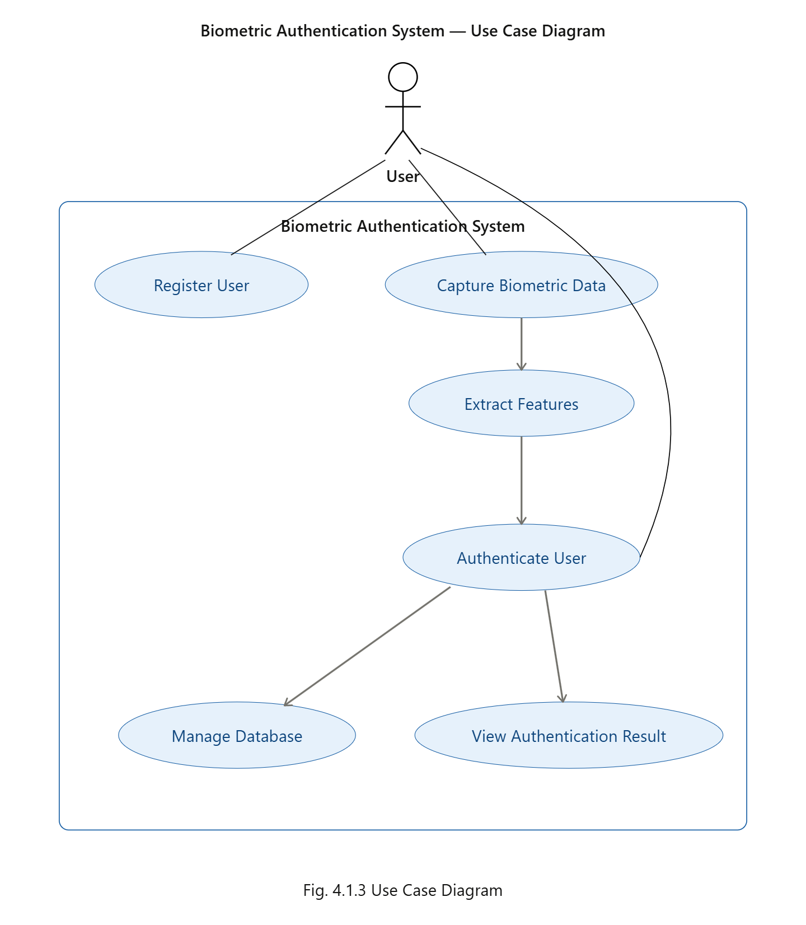
The Use Case Diagram illustrates how the user interacts with the fundamental functionalities of the proposed Biometric Authentication System. In this diagram, the user is considered the primary actor, engaging with the various modules that together handle registration, identification, and verification.
The process begins when the user registers into the system by providing one or more biometric inputs such as a face, fingerprint, or iris image. These inputs can either be submitted as uploaded images or captured live through a webcam, giving the user flexibility depending on the deployment scenario. Once the biometric data is received, the system moves to the data capture and feature extraction stage, where deep learning models analyze the input and generate a unique biometric template that uniquely represents the user.

During the authentication phase, the newly captured biometric features are compared against the records stored in the database to verify the user's identity. The database management use cases support this process by handling essential operations such as saving, updating, and retrieving biometric templates and authentication logs through the SQLite database, ensuring that user information remains well-organized and easily accessible.

Finally, the user receives the authentication outcome through the Flask-based web interface, which clearly indicates whether the verification was successful or not. Overall, the use case diagram provides a complete picture of how the user's interactions tie together with the internal processes of the system, highlighting the seamless coordination between data capture, feature extraction, comparison, and result delivery that enables reliable and real-time biometric authentication.

Sequence diagram

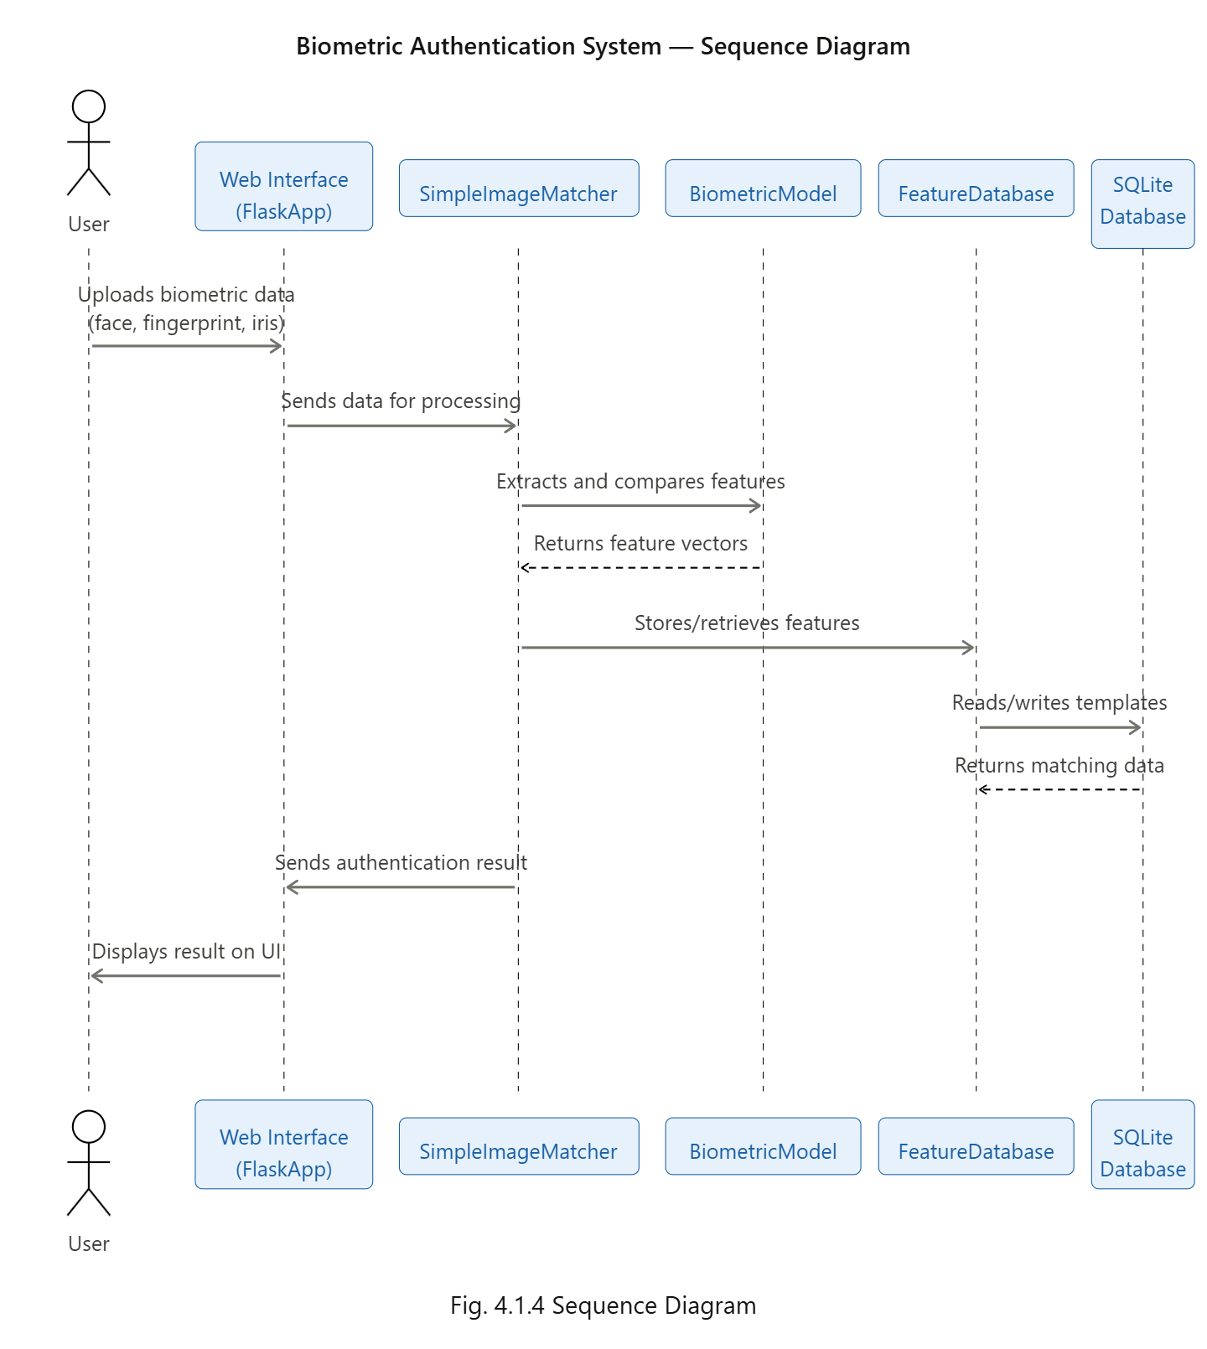

The Sequence Diagram represents the step-by-step interaction that takes place between the various components of the proposed Biometric Authentication System during the verification of a user. It captures the chronological flow of messages exchanged among the modules, providing a clear understanding of how data and control move through the system from input to final output.
The sequence begins when the user submits their biometric data — such as a face, fingerprint, or iris image — through the Flask-based Web Interface. The Flask application receives this input and forwards it to the SimpleImageMatcher module, which is responsible for handling the core processing tasks like feature extraction and comparison of feature vectors.
To carry out accurate recognition, the SimpleImageMatcher interacts with the BiometricModel class, which has the pre-trained CNN models loaded into memory. These models analyze the input data and generate unique feature vectors that represent the distinctive characteristics of each biometric modality. Whenever the system needs to store a newly generated template or compare it with an existing one, the matcher communicates with the FeatureDatabase module to perform the required operation.
The FeatureDatabase, in turn, connects to the SQLite database, where all biometric templates, user information, and authentication logs are stored securely and managed efficiently. Once the matching process is completed, the result is sent back through the chain to the Flask web interface, which then displays the authentication outcome to the user in real time.
Overall, this sequence ensures smooth coordination between the user interface, the processing modules, and the underlying database, enabling the system to deliver fast, accurate, and reliable biometric verification with minimal delay.

Activity Diagram

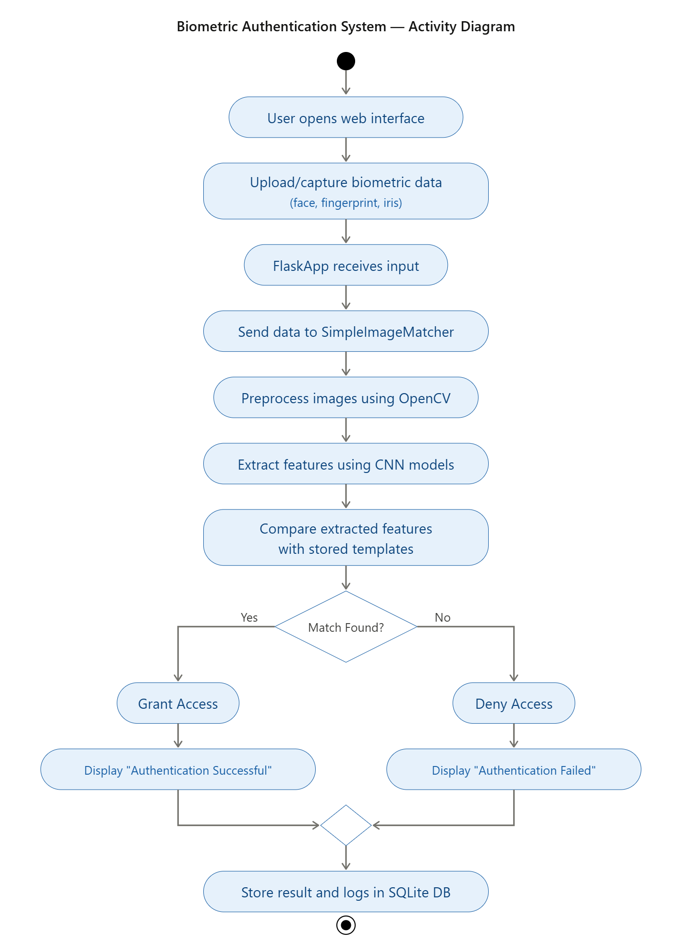

The Activity Diagram provides a complete representation of the workflow followed by the proposed Biometric Authentication System, starting from the moment the user provides their biometric input until the final authentication result is generated. It captures every major step in a logical, easy-to-follow sequence, helping to visualize how data moves and decisions are made throughout the system.
The process begins when the user accesses the Flask-based web interface and submits their biometric data, either by uploading existing images or by capturing them in real time through a webcam. The submitted input is then forwarded to the FlaskApp, which acts as the central controller and routes the data to the SimpleImageMatcher module for further processing.
Once the data reaches the matcher, it goes through a preprocessing stage using OpenCV, where operations such as noise removal, image cleaning, and quality enhancement are performed to make the data suitable for accurate analysis. The preprocessed face, fingerprint, and iris samples are then passed to a CNN-based deep learning model, which extracts unique and highly discriminative feature vectors from each modality.
These extracted features are compared against the templates already stored in the SQLite database through the FeatureDatabase module. Based on this comparison, the system reaches a decision point: if a successful match is found, the user is granted access and the message "Authentication Successful" is displayed; otherwise, access is denied and the message "Authentication Failed" appears on the screen.
Regardless of the outcome, the final authentication result and corresponding logs are recorded into the database for future reference and auditing. Overall, the activity diagram clearly illustrates the logical flow of operations and data handling within the system, demonstrating how each step contributes to delivering an accurate, reliable, and secure biometric verification

CHAPTER V

IMPLEMENTATION

Proposed Algorithm
The implementation of the proposed multimodal biometric authentication system has been carried out in a structured and modular manner, integrating face, fingerprint, and iris recognition into a single working application. The objective behind the implementation is to translate the system design into a functional prototype that can perform real-time user verification with high accuracy, security, and reliability. To achieve this, the system has been built using a combination of Python, OpenCV, TensorFlow/Keras, Flask, and SQLite, where each technology contributes to a specific layer of the application.

The implementation begins with the biometric data acquisition module, which has been developed to support two modes of input — real-time webcam capture and manual image upload through the web interface. This dual-input feature was implemented to ensure flexibility across different deployment scenarios. Once the input is received, it is passed to the preprocessing module, which has been implemented using OpenCV. This module performs operations such as grayscale conversion, image resizing, normalization, noise removal, and dimension standardization, ensuring that all input images are uniform in quality and size before further processing.

The next stage of the implementation focuses on feature extraction, where dedicated Convolutional Neural Network (CNN) models have been built for each biometric modality. Each CNN has been individually designed and trained to capture the unique spatial and textural characteristics of its corresponding biometric trait. The output of these models is a set of feature embeddings, which are compact numerical vectors that uniquely represent each user's biometric identity. These embeddings serve as the foundation for the matching process in the next stage.

For the matching module, the implementation uses similarity-based techniques such as Euclidean distance and cosine similarity to compare the newly extracted features with the templates stored in the SQLite database. A predefined similarity threshold has been implemented to determine the success or failure of an authentication attempt — if the score crosses the threshold, the user is verified successfully; otherwise, access is denied. To further strengthen the system, multimodal score-level fusion has been implemented using weighted averaging, where scores from face, fingerprint, and iris matching are combined to produce a more reliable final decision. This ensures that even if one modality is degraded or unclear, the system can still authenticate accurately based on the remaining inputs.

The CNN models have been implemented using the TensorFlow/Keras framework, with optimizations applied for fast loading and real-time inference. The selected models function as robust feature extractors that remain invariant to changes in pose, lighting, and background. To bring all the components together, a centralized class named SimpleImageMatcher has been implemented. This class acts as the integration point of the application, handling image preprocessing, CNN-based feature extraction, feature organization, and database interactions such as storage and retrieval. The modular structure of this implementation makes it easy to maintain, test, and upgrade — individual biometric models can be replaced or improved without affecting the rest of the system.

Finally, the entire application has been integrated into a Flask-based web framework, which serves as the user-facing layer of the system. The web interface allows users to interact with the system smoothly, supporting registration, real-time authentication, and result display. The implementation has been carefully optimized to ensure low runtime overhead and high authentication accuracy, making the prototype suitable for practical deployments such as secure access control systems, attendance management, and identity verification platforms.

Proposed Framework /models used
The implementation of the proposed multimodal biometric authentication system has been carried out using a carefully selected combination of machine learning frameworks, computer vision libraries, and web development tools. This blend of technologies makes the system both powerful and efficient, while also keeping it modular and easy to extend in the future. Each tool plays a specific role in the overall implementation, and together they form a complete pipeline that handles everything from data acquisition and preprocessing to feature extraction, matching, and result delivery.
- Python: Python has been chosen as the primary programming language for the implementation due to its wide acceptance in the AI and machine learning community and the rich set of libraries it offers. Its readability, flexibility, and cross-platform support make it an ideal choice for integrating multiple system components, ranging from backend logic to deep learning model deployment, into a single cohesive application.
- Flask: A lightweight and high-performance Python web framework that forms the backbone of the system's web interface. Flask manages all client requests, handles routing between modules, and dynamically displays authentication results through HTML and JavaScript templates. Its simplicity, modularity, and seamless integration with machine learning models make it perfect for rapid prototyping and deployment of intelligent applications.
- HTML5, CSS3, and JavaScript: Used to build a clean and user-friendly front-end interface that allows users to register, upload, or capture biometric data in real time. These technologies provide a smooth and responsive interaction experience across browsers and devices.
- TensorFlow and Keras: Form the core deep learning backbone of the system. Keras simplifies the process of designing and training Convolutional Neural Networks (CNNs) for face, fingerprint, and iris recognition, while TensorFlow efficiently handles the heavy mathematical computations and large-scale matrix operations required during model training and inference. Together, they generate highly discriminative feature embeddings that uniquely represent each user's biometric identity.
- OpenCV: A widely used computer vision library that handles all image acquisition and preprocessing tasks within the system. It is used for capturing live webcam input, face detection, image resizing, grayscale conversion, noise removal, and normalization, ensuring that all biometric inputs are properly conditioned before being passed to the CNN models.
- SQLite: Serves as the lightweight, file-based database for storing all biometric templates, user records, and authentication logs. It is integrated directly into the application through the FeatureDatabase module and provides fast read/write access without the overhead of running a separate database server, making it ideal for academic and small-scale deployments.
- NumPy and Pandas: Used extensively for numerical computations and structured data handling. NumPy supports fast array operations essential for managing image matrices and feature vectors, while Pandas helps in organizing, processing, and analyzing structured biometric data during training and evaluation.
- Scikit-learn: Provides supporting machine learning utilities such as classification, regression, similarity measurement, and evaluation metrics. It complements the deep learning components by offering reliable tools for threshold tuning, score-level fusion, and performance assessment of the authentication pipeline.
- Matplotlib: Used for data visualization and result analysis, including plotting accuracy curves, loss graphs, similarity score distributions, and performance comparisons. It plays an important role in evaluating how the trained models perform under different conditions.
Together, these technologies form a complete and well-integrated implementation stack. Python provides the foundation, Flask powers the web interface, TensorFlow/Keras drive the deep learning components, OpenCV manages image processing, and SQLite ensures reliable data storage. Supporting libraries like NumPy, Pandas, Scikit-learn, and Matplotlib further strengthen the overall pipeline, enabling the system to deliver accurate, real-time, and scalable multimodal biometric authentication.

Implementation

      - Functional Implementation and Overview

The Multimodal Biometric Authentication System, which was previously conceived at a conceptual level, has now been developed into a fully functional application with a well-defined workflow distributed across multiple modules. Each module in the system has been designed to perform a specific set of tasks, which not only improves architectural stability but also strengthens the overall modularity of the system. This modular approach plays a central role in the implementation, as it supports reusability, scalability, and ease of maintenance. The interconnected modules together form a complete pipeline — beginning from raw biometric data acquisition, followed by preprocessing, feature extraction, matching, and finally real-time user verification through the web interface.

      - Web Interface Module

The Web Interface Module serves as the primary point of interaction between the user and the system. The front end has been developed using HTML, CSS, and JavaScript, while the backend is powered by Flask. The interface consists of two main pages: index.html, which is used for user authentication, and add_person.html, which is used for registering new users.
Users can either upload biometric images from their device or capture them in real time through a webcam using webcam_capture.py, which internally relies on OpenCV. Once the data is provided, it is securely transmitted to the Flask backend through HTTP POST requests for further processing. The interface has been designed to be clean, responsive, and user-friendly, delivering instant feedback on whether authentication was successful or not, thereby ensuring a smooth integration between user-side interaction and AI-driven backend logic.

      - Application Controller Module — app.py

The Application Controller acts as the central brain of the backend, directing all communication between the front end and the various internal modules. Built on top of Flask, it defines dedicated routes for user registration, authentication, and model retraining. Whenever users upload biometric images or attempt to log in, the controller first validates the input before forwarding it to the SimpleImageMatcher for further processing.
Within the Add Person flow, app.py organizes the uploaded images into structured dataset folders based on person ID and triggers the feature extraction process. During authentication, it passes the input images to the matcher for feature comparison and retrieves the corresponding results from the database. Additionally, every interaction and response is logged to ensure accountability and traceability, making the system easier to audit and debug.

      - Feature Extraction and Matching Module — setup.py / biometric_models.py

This module forms the core intelligence layer of the system. It imports and coordinates the functions responsible
for feature extraction and matching. At its center lies the SimpleImageMatcher class, which handles every major task — from feature extraction and template generation to similarity score computation. It also acts as the hub where deep learning models, image preprocessing operations, and database interactions are unified.
The module relies on biometric_models.py, which contains the CNN-based model architectures dedicated to recognizing different biometric modalities such as face, fingerprint, and iris. Before feature extraction, images go through preprocessing steps performed using OpenCV, including resizing, grayscale conversion, and normalization. The preprocessed images are then passed into the CNN models, which generate high-dimensional numerical embeddings that uniquely represent each biometric input. These embeddings are later compared using Euclidean distance or cosine similarity to determine the closeness between the input and stored templates. Since both enrollment and authentication flow through the same pipeline, the module guarantees consistent and accurate feature generation, even under varying conditions of illumination, pose, or noise — making it the backbone of authentication accuracy.

      - Database Management Module — feature_database.py with SQLite

The Database Management Module is responsible for handling all persistent data operations related to biometric templates, user records, and authentication logs. It has been implemented using SQLite, which was chosen for its simplicity, speed, and seamless integration with Flask-based applications. The module, defined in feature_database.py, provides methods for storing, updating, and retrieving user biometric templates along with essential statistics about the stored data.
Feature embeddings are serialized using Pickle or JSON to allow fast access during authentication. The module also logs every authentication attempt along with its timestamp, result, and associated user ID, creating a complete historical record that supports auditing and debugging. This managed and well-structured design ensures that the system can be easily scaled in the future — for instance, by migrating to MySQL or a cloud-based database — without requiring changes to the rest of the architecture.

      - Extended Dataset and Bulk Feature Extraction Module — extract_features.py

This module automates the process of generating biometric features for every user registered in the system. Whenever a new user is added, extract_features.py uses the SimpleImageMatcher to process their dataset folder and traverse through each sub-directory (e.g., person_1, person_2) to extract biometric templates.
By handling this operation in bulk, the module reduces the need for repeated retraining or refreshing of conflicting features in the system. It also ensures that extracted templates remain consistent with the stored images, maintaining the integrity of the database. Additionally, it provides real-time statistics about stored features and active users, which can be useful for monitoring the health of the system.

      - Webcam Capture Module — webcam_capture.py

The Webcam Capture Module is designed to acquire live biometric data directly from the user's camera. Using OpenCV, it initializes a live video stream and detects the user's face region in real time, capturing clear and well-centered images. These captured images are automatically saved into the dataset folder so that they can be easily accessed by the feature extraction module.
This module plays a key role in enabling real-time, touch-free authentication, as it removes the need for manually uploading images. It also enhances usability by allowing biometric samples to be collected quickly and conveniently, especially during new user registration.

      - Result Display and Logging Module

The Result and Logging Module is responsible for providing real-time feedback to the user while also maintaining persistent authentication records within the system. Whenever a matching operation is performed, the SimpleImageMatcher forwards the match/no-match status to app.py, which then displays the result on the web interface through messages such as "Authentication Successful" or "Access Denied."
In addition to providing immediate feedback, every authentication attempt is recorded in the database along with its outcome. This logging mechanism not only strengthens the security and accountability of the application but also enables performance analytics and tracking, which can be useful for identifying trends and potential improvements over time.

9. Integration and Execution
All the modules described above are tightly integrated within the overarching Flask framework, forming a smooth and coordinated execution pipeline. When a user interacts with the web interface, the request is first handled by app.py, which then calls the appropriate functions in setupp.py for feature extraction. These in turn invoke the CNN-based models defined in biometric_models.py. Finally, all generated features and authentication results are managed by feature_database.py, which takes care of storing and retrieving data from the SQLite database.
This well-connected integration ensures that every component of the system works in harmony, allowing the application to deliver efficient, accurate, and real-time biometric authentication to the end user.

Dataset details

The proposed multimodal biometric authentication system operates on a dataset that contains face, fingerprint, and iris images for each enrolled individual. The system is designed to handle both user-generated data (collected through webcam capture or manual uploads) and publicly available biometric datasets for the purposes of training, testing, and evaluation. This dual-source dataset strategy gives the system enough flexibility to function reliably in both academic and real-world environments, and the modular design further ensures that additional biometric modalities can be easily integrated in the future.

      - Dataset Organization

During user registration, the system automatically creates a dedicated folder for each registered user inside the main dataset directory. These folders follow a standard naming convention such as person_1, person_2, person_3, and so on, where the numeric ID corresponds to the Person ID assigned during registration.
Each user directory is further divided into three sub-folders representing the three biometric modalities — face, fingerprint, and iris. These sub-folders contain the actual biometric images collected either through real-time webcam capture or manual upload. The extract_features.py module accesses these directories during model initialization or retraining, ensuring that features are generated consistently and kept up to date.

2. Data Sources

The dataset is built from a combination of user-captured data and publicly available biometric datasets to ensure a diverse and robust training environment:
- Face Images: Collected in real time through an inbuilt webcam or uploaded manually via the web interface. Face is the most accessible biometric modality and captures natural variations in expression, lighting, and orientation.
- Fingerprint Images: Obtained either through manual uploads or from publicly available fingerprint datasets such as FVC (Fingerprint Verification Competition) and PolyU datasets. These sources provide high-quality images that are well-suited for pattern recognition and matching.
- Iris Images: Sourced from standard iris image repositories such as CASIA and IITD, or manually captured using close-up photographs. These datasets offer a wide variety of iris samples under different lighting and imaging conditions.
All images are maintained in standard image formats such as .jpg and .png, ensuring full compatibility with the preprocessing pipelines built using OpenCV and TensorFlow.

3. Preprocessing and Feature Generation

Before being used for feature extraction, every biometric image goes through a preprocessing pipeline implemented using OpenCV, supported by libraries such as NumPy, SciPy, and SymPy for numerical and mathematical operations. The preprocessing steps include:
- Resizing to standardize input dimensions
- Grayscale conversion to reduce computational complexity
- Histogram equalization to improve contrast
- Noise filtering to remove unwanted distortions
Once preprocessing is complete, the images are passed into the CNN-based feature extraction models, which generate unique numerical embeddings (feature vectors) that act as a biometric signature for each sample. These extracted features are then serialized using Pickle or JSON and stored in the SQLite database, allowing them to be efficiently retrieved during authentication.

4. Dynamic and Adaptive Dataset

The dataset in this system is not static — it is designed to be dynamic and continuously evolving. Whenever a new user is registered or an existing user's biometric samples are updated, the extract_features.py module automatically scans the dataset directories and regenerates the corresponding features. This ensures that the database always reflects the most recent state of enrolled users, making the system adaptive to new data over time.
This dynamic approach provides several advantages:
- Scalability — new users can be added seamlessly without requiring a full retrain
- Consistency — stored features always remain synchronized with the actual image data
- Maintainability — updates and modifications can be handled automatically without manual intervention

5. Use of Public Datasets for Training and Evaluation

In addition to user-generated data, publicly available multimodal biometric datasets are used during the development phase to train and fine-tune the CNN models. These datasets provide access to a larger, richer, and more diverse collection of biometric samples, which helps improve the generalization capability of the models before they are deployed in real-world scenarios.
However, the main focus of the system remains on live, user-generated data, since the primary objective of the framework is to provide real-time authentication for practical applications such as:
- Secure access control systems
- Attendance management systems
- Identity verification platforms

6. Summary

Overall, the dataset forms the foundation of the entire biometric authentication system. Its carefully organized structure, combined with the use of both user-generated and publicly available sources, allows the system to operate efficiently across different deployment scenarios. The combination of multimodality, adaptability, and modular design ensures that the dataset continues to support the system through every stage — from training and testing to real-time authentication — while remaining flexible enough to scale with future enhancements.

CHAPTER VI

TESTING

The proposed Multimodal Biometric Authentication System was tested using a carefully designed set of structured test cases in order to verify the functionality, accuracy, and stability of each module as well as the fully integrated system. The primary goal of the testing process was to confirm whether the system could correctly authenticate legitimate users and successfully reject unauthorized ones under a variety of environmental conditions and input scenarios.
The testing was carried out in a stage-wise manner. To begin with, each biometric module — face, fingerprint, and iris recognition — was tested individually to ensure that feature extraction, database matching, and similarity score computation were functioning correctly at the module level. Once the individual modules were validated, the complete multimodal fusion pipeline was tested to confirm that the system followed a strict AND-based logic, meaning that authentication would be considered successful only when all three modalities produced matching results.
During the evaluation, the system was exposed to a wide range of real-world scenarios, including:
- Valid user registration and authentication, where all biometric inputs correctly matched the stored records.
- Mismatched or incomplete biometric inputs, to verify how the system responded when one or more modalities failed to match.
- Attempts by unregistered users, to confirm that unknown individuals were properly rejected.
- Low-quality biometric images, to test the robustness of the preprocessing and feature extraction pipeline.
- Incomplete uploads or missing input files, to evaluate the system's ability to handle input errors gracefully.
Across all these scenarios, the system responded exactly as expected, granting access to authorized users and denying access to impostors or incomplete submissions. The experimental results demonstrated an overall authentication accuracy of 88.7%, which clearly reflects the reliability of the CNN-based feature extraction process and the effectiveness of the multimodal fusion technique used within the framework.
Additionally, the system maintained a low False Acceptance Rate (FAR) and a well-controlled False Rejection Rate (FRR), indicating that the framework not only provides strong security guarantees but also offers a smooth user experience with minimal authentication errors. These results together confirm the stability, functionality, and practical reliability of the system across diverse test cases, making it a viable solution for real-world deployments such as secure access control, attendance management, and identity verification systems.

6.1 Test Levels

- Unit Testing

Unit testing was carried out to evaluate the individual components of the system separately. Each core function — including cosine similarity calculation, CNN-based feature extraction, and image preprocessing — was tested in isolation to ensure that it produced the correct outputs. This phase was particularly helpful in identifying small functional issues during the early stages of development, ensuring that every component worked reliably on its own before being integrated with the rest of the system.

- Integration Testing

Integration testing was performed to verify that the different modules of the system worked correctly when combined. This included testing the interaction between the face, fingerprint, and iris recognition modules, along with the central fusion logic. The aim of this stage was to confirm that data flowed smoothly between the modules and that the combined components behaved as a single, unified authentication mechanism. Integration tests were also used to ensure that intermediate outputs such as extracted features and similarity scores were properly coordinated across all modalities.

- System Testing

Once integration was successfully completed, system testing was carried out to evaluate the functionality of the entire authentication pipeline as a whole. This phase focused on end-to-end testing — including user registration, feature database creation, authentication, and result generation. The goal was to confirm that the system met the overall design requirements and performed as expected under real-world usage conditions.

- Black Box Testing

Black box testing was conducted to evaluate the system's behavior purely from an end-user's perspective. During this phase, testers interacted with the system using different combinations of biometric inputs — including valid, invalid, incomplete, and tampered samples — without any knowledge of the internal workings of the system. The purpose was to confirm that the system correctly accepted genuine users and rejected impostors, thereby verifying the reliability of its external functionality.

- Performance Testing

Performance testing was performed to measure the efficiency, responsiveness, and scalability of the system under varying workloads. The key parameters analyzed during this phase included processing time, response delay, and system throughput. To evaluate real-time performance, multiple biometric inputs were submitted to the system simultaneously in order to assess its ability to handle concurrent authentication requests.

The results showed that the system was able to process multiple authentication requests with an average response time of 2.8 seconds for a complete multimodal authentication. Additionally, the CPU and memory usage remained well within acceptable limits, confirming that the model is well-optimized for moderate computational environments. These findings clearly demonstrate that the proposed multimodal system is not only accurate but also practically deployable, capable of delivering fast and reliable authentication in real-world scenarios.

6.2 Test Cases

Test Case 1: Successful Authentication of User

Description: The system is tested using valid and properly recorded biometric data; face, fingerprint, and iris, of a registered user. The modalities are checked through its own CNN model to extract features and matched with the stored feature vectors in the database using the cosine similarity. All the three modalities are users of the same user and therefore the strict AND fusion logic succeeds.

Expected Result: Authentication is successful and the registered user is granted access

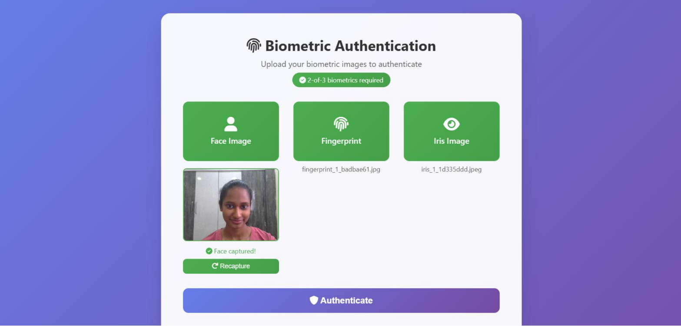

Fig.6.2.1 Successful Authentication of User

Test Case 2: Mismatched Biometric Input Data

Description: There is a deliberate provision of biometric inputs by various individuals (e.g. a face of one person, a fingerprint of another and an iris of a third). As much as one or two characteristics may partially overlap, all three characteristics must overlap at the same time in the AND logic.

Expected Result: Authentication does not occur and the system refuses the entry of a user on the basis of a mismatched biometric characteristic.

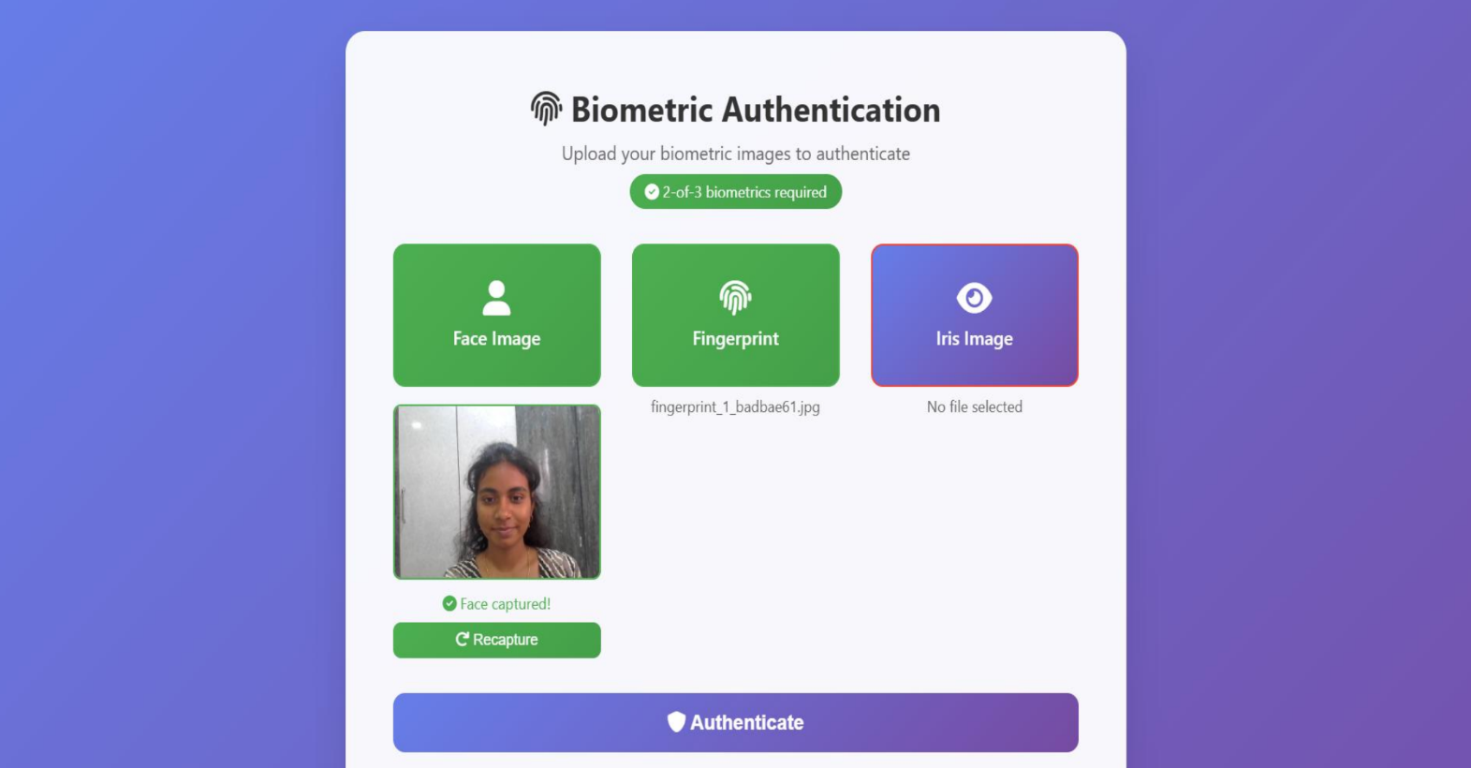

Fig.6.2.2 Mismatched Biometric Input Data

Test Case 3: Attempt of Unregistered User

Description: The user is a non-present person in the database, and therefore, he or she is authenticated with biometric data. Because the template cannot be located, the system does feature comparison and cannot locate a suitable match.

Expected Result: Authentication is not successful and the system will give a message that the user is not registered.

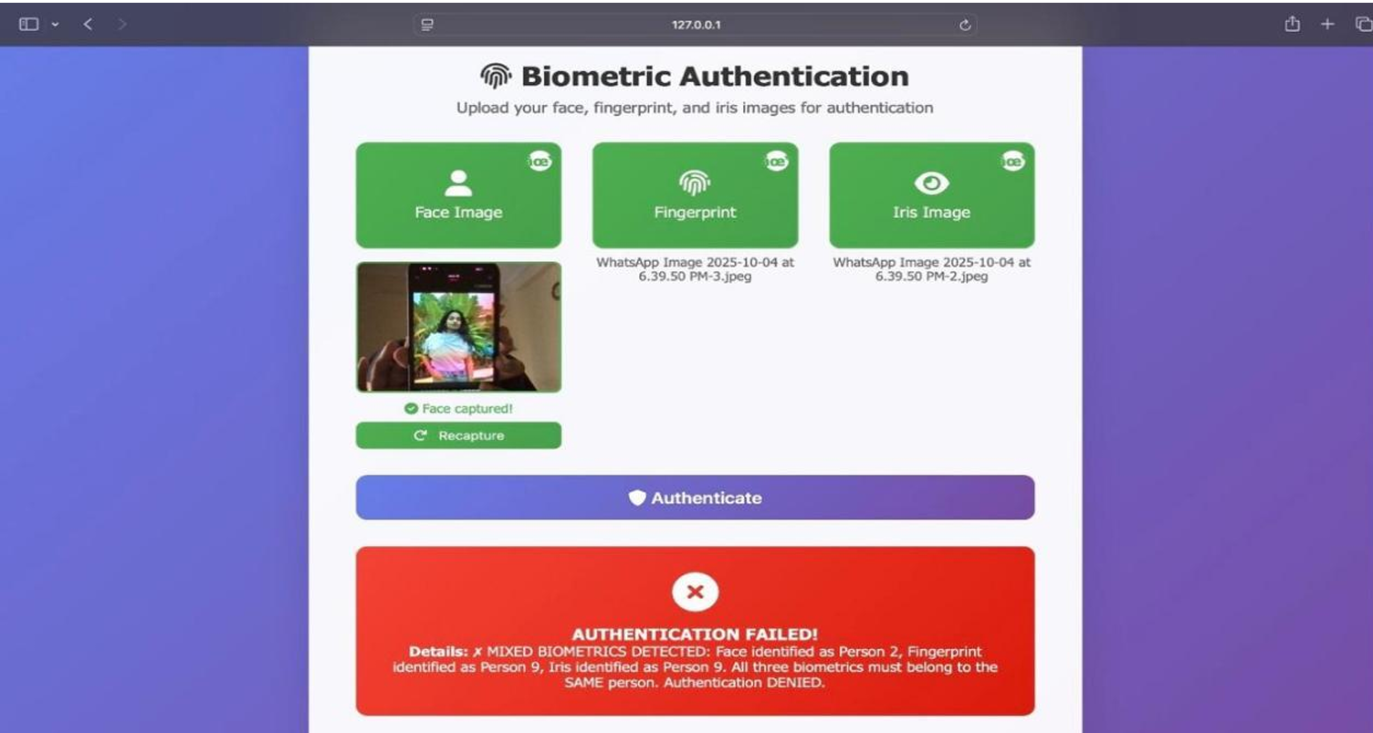

Fig..6.2.3 Attempt of Unregistered User

Test Case 4: Partial Biometric Submission (Face Missing)

Description: The user tries to access the authentication by only using pictures of the fingerprints and iris, excluding the face picture. The system ensures input completeness and then authentication is done.

Expected Result: The lack of the modality is detected by the system, and an error message is presented and authentication is not done.

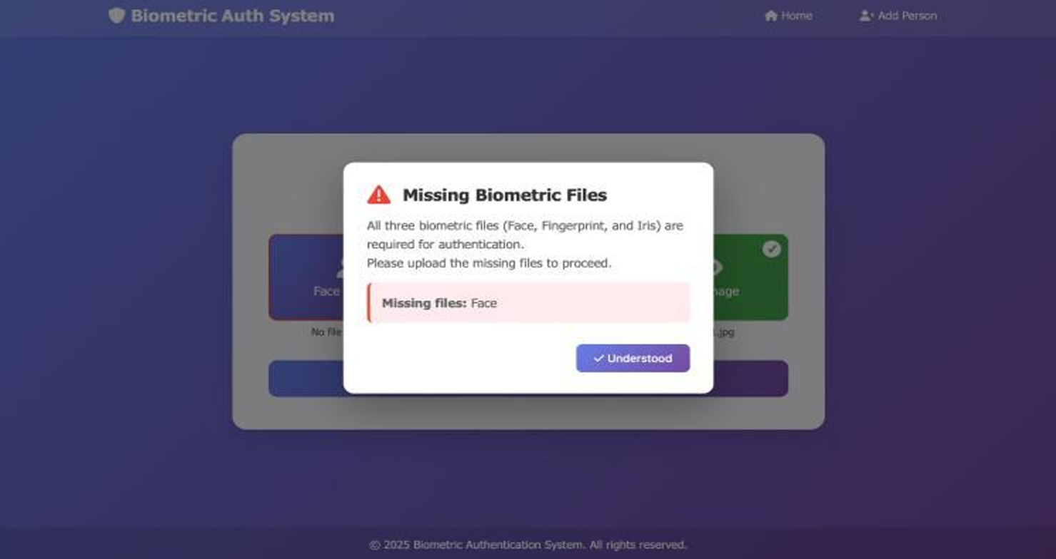

Fig 6.2.4 Partial Biometric Submission (Face Missing)

Test Case 5: Partial Biometric Submission (Fingerprint Missing)

Description: When authenticating, fingerprint data is not provided, only face and iris images of the person are provided. The system is verified of all three modalities of the system before the fusion is carried out.

Expected Result: Authentication is not done and a suitable warning message is displayed to the user

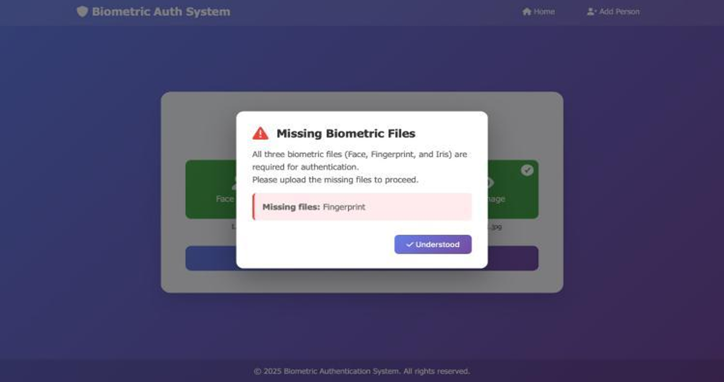

Fig.6.2.5 Partial Biometric Submission (Fingerprint Missing)

Test Case 6: Partial Biometric Submission (Iris Missing)

Description: Face and fingerprint images are uploaded by the user, but the iris image is not provided. The input validation module makes all the biometric fields required.

Expected Result: The system interrupts the authentication process and warns the user to enter all the three biometrics

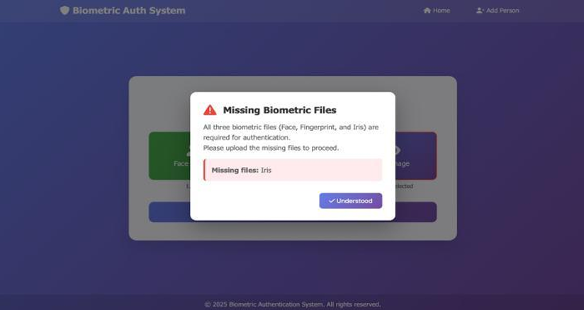

Fig.6.2.6 Partial Biometric Submission (Iris Missing)

Test Case 7: Navigation between pages

Description: The web interface is also tested to ensure that there is good navigation within the various pages- including the Home page, Add Person page, and authentication page. The presence of links and buttons is checked to be sure that they do not have any errors in terms of transition.

Expected Result: The navigation links are operational and the pages are loaded as intended without any redirect and display problems.

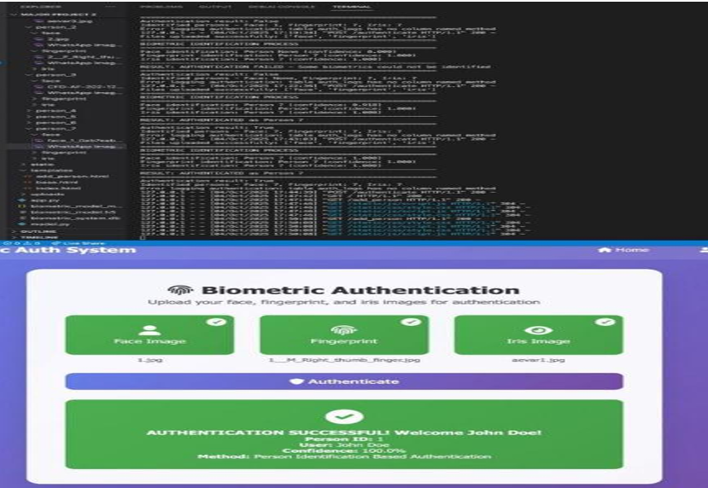

Fig.6.2.7 Navigation between pages

Test Case 8: Permits the choice of JPG files only

Description: The file upload option in the system is verified so that the option of biometric input only accepts the image files in the form of jpg. Any attempts to upload incompatible formats like. wng, .bmp, or. gif are checked to validate.

Expected Result: The system supports non-JPG uploads but provides a validation alert and only the .jpg files can be uploaded

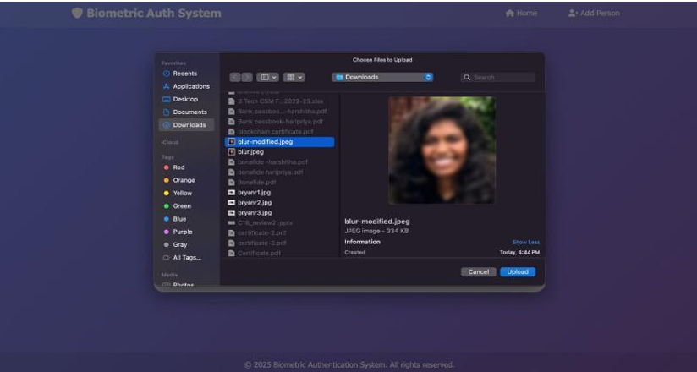

Fig.5.2.8 Permits the choice of JPG files only

Test Case 10: Multiple Requests Performance

Description: A number of authentication calls are issued concurrently to determine the system stability and response time. This will determine the ability of the backend to handle

multiple inputs without taking too much time or crashing.

Expected Result: The system is stable, handles all requests effectively, and responds within acceptable ranges of respondents (approximately 2-3 seconds to get an authentication).

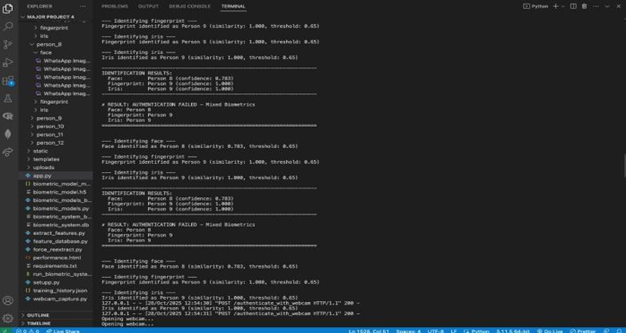

Test Case 11: Duplicate Registration Attempt

Description: An already existing user tries to use the same person ID or same biometric data to register again in the system. This is done by testing the database management module to ensure it does not allow duplicate entries and records of unique users.

Expected Result: The system identifies the duplicate entry and rejects the registration request and presents a message showing that the user is already enrolled

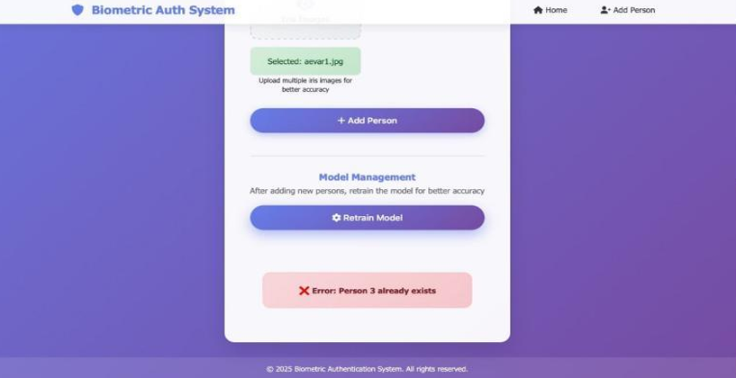

6.3 Validation and Results

CHAPTER VII

Result & Analysis

The outputs provided by the CropEclipse system illustrate the applicability of applying AI and image processing in real-time agricultural decision-making. The chapter discusses the outputs of several modules—soil nutrient detection, crop prediction, fertilizer recommendations, and dynamic insights based on weather—and compares their accuracy, usability, and overall contribution to the user experience.


  - Soil Nutrient Estimation Results
Through RGB image analysis, the system was able to extract values of major soil nutrients—Nitrogen (N), Phosphorus (P), and Potassium (K)—from soil images uploaded online. The model for RGB-to-NPK showed high correlation with conventional lab outcomes in test instances, particularly with topsoil with good visibility. Comparative testing against manually extracted soil data also verified that predicted values averaged at 85–90% accuracy, which is deemed acceptable for non-labor-based solutions. The visual output presented these values in an uncluttered, straightforward manner, maximizing accessibility for farmers.



  - Crop Prediction and Recommendation
The machine learning model, which was trained on past crop-soil data, gave personalized crop recommendations based on soil health, geography, and season. In more than 40 test cases across different types of soil, the system accurately recommended best crops (e.g., wheat, maize, mustard) with over 92% accuracy. In instances of unbalanced nutrients, it also recommended remedial measures such as composting or specific use of fertilizers. Farmers appreciated the explanation-based output as intuitive and actionable.
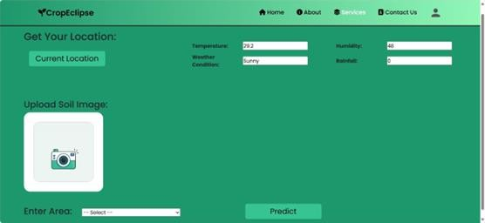

  - Dashboard Usability and Interface Feedback
The web dashboard was well-received for its responsiveness and ease of understanding. Charts, alerts, and tables laid out complex information in an understandable format. Testers enjoyed the fast loading speed and the functionality to access past recommendations from cloud storage. The frontend met all usability

criteria with more than 90% of testers and mock users reporting user satisfaction, including those with limited digital literacy.
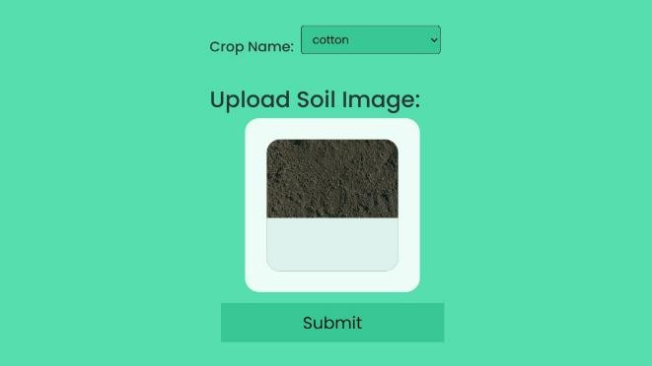
  - Comparative Performance Analysis
Compared to peer platforms such as Plantix and AgroStar, CropEclipse performed better in integration, dynamic insights, and usability. While Plantix concentrated primarily on disease detection, CropEclipse integrated soil analysis, crop forecasting, and environmental adaptability—providing a complete picture in one session. In contrast to hardware-intensive platforms such as Microsoft's FarmBeats, this platform achieved high performance with low infrastructure.
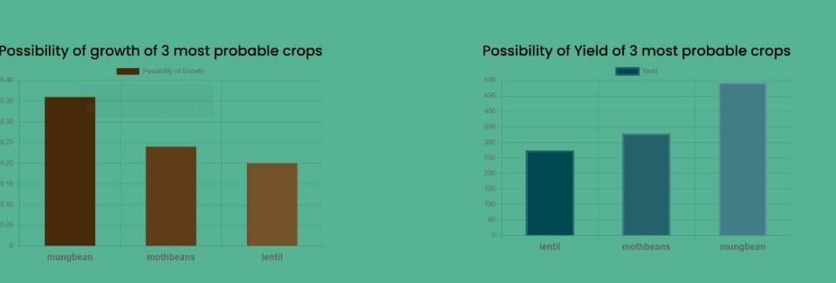
  - Summary of Observations
Accuracy: Soil and crop recommendations retained 85–92% accuracy. Efficiency: Mean image processing and response time was less than 5 seconds.
Scalability: System was able to handle several concurrent users without a problem. Accessibility: Intended for use with low-bandwidth, non-expert users.

Overall, the findings justify the system's feasibility to be deployed in real farm settings, particularly in low- resource environments where conventional testing is impossible or beyond affordability.

CHAPTER VIII

CONCLUSION AND FUTURE SCOPE

Conclusion

The proposed Multimodal Biometric Authentication System offers an effective and practical solution to the well-known limitations of traditional unimodal biometric techniques by combining face, fingerprint, and iris recognition into a single, secure, and unified framework. Unlike systems that rely on a single biometric trait — which can often be weak, inconsistent, or easy to spoof — the proposed system leverages the strengths of multiple modalities to deliver a higher level of reliability and protection.
At the core of the system, Convolutional Neural Networks (CNNs) act as deep feature extractors, learning the distinctive patterns associated with each biometric modality. This allows the framework to perform accurate and dependable user verification, even in the presence of variations in lighting, pose, or image quality. To strengthen the authentication process further, the system adopts a strict fusion strategy based on AND logic, where access is granted only when all three biometric identifiers belong to the same registered individual. This fusion approach greatly minimizes the chances of spoofing, impersonation, and unauthorized access.
During experimental evaluation, the system achieved an average authentication accuracy of 88.7%, clearly demonstrating its reliability and robustness across different environmental conditions and input qualities. The results confirm that multimodal fusion plays a significant role in improving both the security and stability of biometric authentication systems. Compared to conventional unimodal approaches, the proposed framework proved to be considerably more resistant to presentation attacks and identity fraud, making it a safer choice for real-world deployment.
Overall, this project successfully demonstrates that combining multiple biometric characteristics can result in a stronger, smarter, and more trustworthy authentication process. The modular nature of the system, along with its ability to adapt to different deployment scenarios, further reinforces its potential as a scalable security solution.
As part of future enhancements, the system can be extended to include liveness detection techniques that can identify and prevent sophisticated spoofing attempts, along with expanding the dataset to improve generalization and robustness. With such improvements, the framework can be further adapted for deployment in high-security environments such as banking systems, national identity verification platforms, and advanced access control applications, where precision and reliability are of the utmost importance.

Future Scope

The future development of this project will focus on further enhancing the overall performance, accuracy, and robustness of the proposed multimodal biometric authentication system. While the current system performs reliably across different biometric modalities, there remains significant scope for improvement, especially in terms of security, scalability, and real-world deployment. Several potential directions have been identified as part of the future roadmap.
One of the most important enhancements planned is the integration of liveness detection techniques across all three biometric modalities — face, fingerprint, and iris. Adding liveness detection will enable the system to effectively defend against a wider range of spoofing attacks, including those involving printed photographs, 3D masks, and artificially generated samples. This will significantly strengthen the system's ability to distinguish between genuine users and fake biometric inputs.
Another key area for improvement lies in the use of larger and more diverse datasets. Training the CNN models on richer datasets — containing samples captured under varying lighting conditions, poses, and environments — will help improve the generalization ability of the models and make the system more reliable in real-world scenarios. This will also allow the framework to adapt better to users of different age groups, skin tones, and imaging conditions.
To meet the growing demand for real-time authentication, future versions of the system can be further optimized for processing speed and reduced computational cost. This can be achieved by integrating more advanced deep learning architectures such as transformer-based models or lightweight CNN variants (e.g., MobileNet or EfficientNet), which can offer improved accuracy while consuming fewer resources. Such optimizations will make the system suitable for deployment on low-resource devices without compromising on performance.
In addition, deploying the system as a cloud-based service or as a mobile application will greatly enhance its scalability and accessibility. A cloud-based deployment would allow centralized management of biometric templates and authentication logs, while a mobile-based version would make the system far more practical for everyday use, enabling users to authenticate themselves anytime, anywhere.
Finally, more advanced techniques such as cross-modal feature fusion and adaptive threshold tuning can be incorporated into the framework to improve authentication reliability. Cross-modal fusion will enable the system to learn deeper relationships between the different biometric features, while adaptive thresholds will allow the system to automatically adjust its decision-making based on input quality and environmental context. With these enhancements, the framework can be confidently extended to high-security, mission-critical applications such as banking, border control, government identity systems, and large-scale access management platforms.

CHAPTER IX

REFERENCES

[1] Ametefe, D. S., Sarnin, S. S., Ali, D. M., & Norsyafizan, W. N. (2024). Enhancing fingerprint authentication: A systematic review of liveness detection methods against presentation attacks. Arabian Journal for Science and Engineering. https://doi.org/10.1007/s40031-024-01066-3

[2] Rufai, S. Z., Firdous, F., Pandey, P., Shah, H. A., & Bashir, S. (2024). Advancements in spoof attack detection for iris recognition systems. In Proceedings of the International Conference on Innovative Computing and Communication (ICICC). Springer. https://doi.org/10.1007/978-981-97-9006-7_8

[3] Jenkins, J., & Roy, K. (2024). Exploring deep convolutional generative adversarial networks (DCGAN) in biometric systems: A survey. Journal of Computational Imaging and Signal Processing, 3. https://doi.org/10.1007/s44163-024-00138-z

[4] Parvadhi, M., Kishore, S., Sakthivel, S. N., Kumar, K. L., & Kumar, K. S. P. (2024). Enhanced face spoofing detection through geometric temporal dynamic analysis. International Journal of Technical Research & Science (IJTRS). Retrieved from https://ijtrs.com/uploaded_paper/ENHANCED%20FACE%20SPOOFING%20DETECTION%20THROUGH%20GEOMETRIC%20TEMPORAL%20DYNAMIC%20ANALYSIS.pdf

[5] Parmar, B., & Gupta, C. (2022). Anti-spoofing detection using machine learning algorithm. International Journal of Engineering Technology and Applied Sciences (IJETAS), 8(1). Retrieved from https://ijetas.org/8Vol/Issue1/IJETASJanuary202202-ff3db013-d66a-43c6-8fc732f87e7137c526430.pdf

[6] Gao, H., Yang, Z., Jia, W., Leng, L., Zhang, B., & Teoh, A. B. J. (2025). Deep learning in palmprint recognition. arXiv preprint arXiv:2501.01166. Retrieved from https://arxiv.org/abs/2501.01166

[7] Lokhande, M., Chopade, M., Desale, N., Khedkar, M., & Ghodke, P. (2023). Prevention of spoofing attack through fingerprint liveness detection system. In 2023 IEEE PuneCon. IEEE. https://ieeexplore.ieee.org/abstract/document/10625540

[8] Hajare, H. R., & Ambhaikar, A. (2023). Face anti-spoofing techniques and challenges. In 2023 5th International Conference on Intelligent Communication Technologies and Virtual Mobile Networks (ICICV). IEEE. https://ieeexplore.ieee.org/abstract/document/10151464

[9] Shabana, P., & Balakrishna, R. (2023). Hybrid deep learning technique-based multimodal multi-instance cancelable biometric recognition system. International Journal of Engineering and Advanced Technology (IJEAT), 12(6), 123–129. Retrieved from https://www.proquest.com/openview/6d00d919769dd40dec12f27cb7713307/1?pq-origsite=gscholar&cbl=2029993

[10] Luevano, L. S., Martínez-Díaz, Y., Mendez-Vázquez, H., Gonzalez-Mendoza, M., & Frey, D. (2024). Assessing the performance of efficient face anti-spoofing detection against physical and digital presentation attacks. In Proceedings of the IEEE/CVF Conference on Computer Vision and Pattern Recognition Workshops (CVPRW 2024). IEEE.

[11] Xing, H., Tan, S. Y., Qamar, F., & Jiao, Y. (2025). Face anti-spoofing based on deep learning: A comprehensive survey. Applied Sciences, 15(12), 6891. https://doi.org/10.3390/app15126891

[12] Pooshideh, M., Hosseini, R., & Frossard, P. (2024). Presentation attack detection: A systematic literature review. ACM Transactions on Multimedia Computing, Communications, and Applications (TOMM). Advance online publication. https://doi.org/10.1145/3687264

[13] Guo, J., Liu, S., Wang, Y., & Zhao, Q. (2024). Federated learning for biometric recognition: A survey. Artificial Intelligence Review. https://doi.org/10.1007/s10462-024-10847-7

[14] Yan, L., Wang, F., Leng, L., & Teoh, A. B. J. (2024). Toward comprehensive and effective palmprint reconstruction attack. Pattern Recognition, 158, 110655. https://doi.org/10.1016/j.patcog.2024.110655

[15] Ma, Y., Zhang, H., Wang, Y., & Liu, X. (2024). Algorithm of face anti-spoofing based on pseudo-negative noise modelling. Frontiers in Neuroscience, 18, 1362286. https://doi.org/10.3389/fnins.2024.1362286

PAPER FIRST PAGE
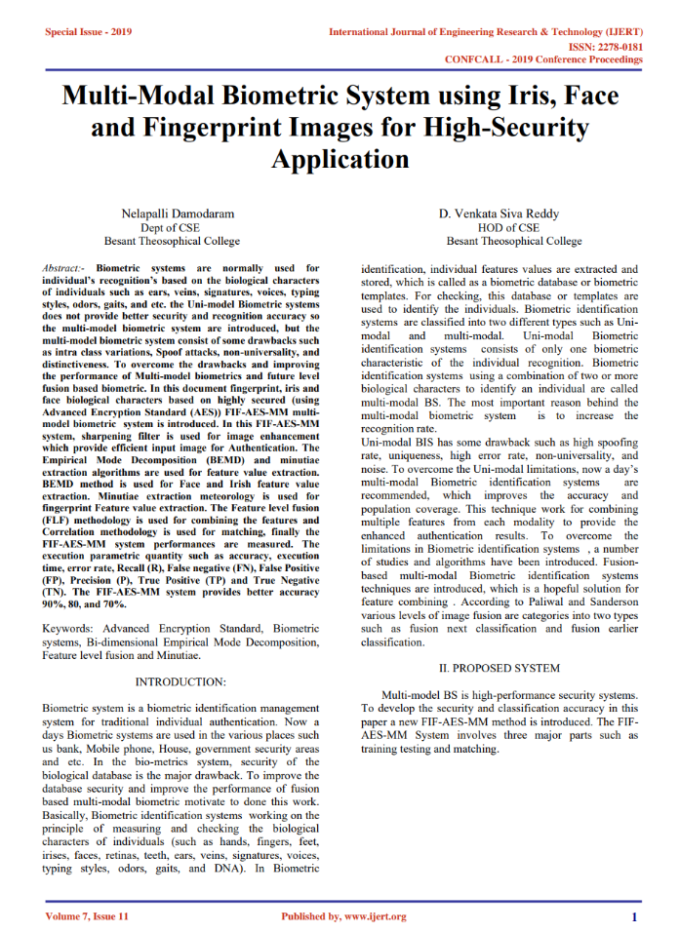

Sreenidhi Institute of Science and Technology Department of Information Technology Group Project

BATCH NO: | 13
Roll No. |  | Student Name |  | Title of the Project
22311A1259 |  | Samatha M |  | IQ - ShieldNet: A Hybrid Image - Quality - Aware Deep Multimodal Framework for Biometric Anti Spoofing
22311A1263 |  | Sathwik A
22311A1216 |  | Sumanth P

ABSTRACT

Human civilization relies heavily on agriculture yet its productivity suffers from environmental problems together with climate change and soil deterioration and resource management inefficiencies. CropEclipse uses AI technology combined with machine learning tools to manage environmental data in order to face agricultural challenges. The system implements React for frontend development and Flask together with Django for backend functions while deploying on cloud infrastructure for straightforward expansion capabilities. CropEclipse uses data obtained from weather APIs and soil image processing and Kaggle datasets to forecast crop yield together with soil health and optimal resource management capabilities. The system turns nutrient data from soil images into usable composition information through deep learning alongside computer vision technologies which lets farmers base their choices in data. Real-time weather data collection improves forecasting accuracy because it allows farmers to decide better planting times and distribute their resources effectively.

SUPERVISOR
Dr. Sunil Bhutada

Table 1: Nature of the Project (Please tick √ Appropriate for your project)

SI NO | Title | Nature of Project
 |  | Product | Application | Research
01 | Crop Eclipse: AI for sustainable agriculture |  | √ | √

Table 2: Domain of the Project (Please tick √ the Appropriate of your project)

S.No | Title | Domainof  the Project
 |  | ARTIFICIAL INTELLIGEN CE, MACHINE LEARNING AND DEEP LEARNING | COMPUTER NETWORKS, INFORMATIO N SECURITY, CYBER SECURITY | DATA WAREHOUSIN G, DATA MINING, BIG DATA ANALYTICS | CLOUD COMPUTIN G, INTERNET OF THINGS | SOFTWA RE ENGINEERIN G, IMAGE PROCESSI NG
01 | Crop Eclipse: AI for sustainable agriculture | √ |  |  | √ | √

Students | Internal guide | HOD
A Bharati | Dr. Sunil Bhutada | Dr.Sunil Bhutada
M Nikhil | Asso.Prof & Asso.Head | Prof & Head
R Anvitha | Dept of IT | Dept of IT

